# Application of Microservice Architecture to B2B Processes

(IBM Watson Customer Engagement)

*by*

**Arpit Jain**

## (2015047)

**Supervisor(s):**

|  |  |
| --- | --- |
| **External** | **Internal** |
| Mr. Atul A. Gohad  (IBM ISL, Bangalore) | Dr. Aparajita Ojha  (PDPM IIITDM Jabalpur) |



**Computer Science and Engineering**

**INDIAN INSTITUTE OF INFORMATION TECHNOLOGY, DESIGN AND MANUFACTURING JABALPUR**

## (11st July 2018 – 26th July 2018)

# Introduction

The International Business Machines Corporation (IBM) is an American multinational [technology company](https://en.wikipedia.org/wiki/Technology_company) headquartered in [Armonk, New York](https://en.wikipedia.org/wiki/Armonk,_New_York), [United States](https://en.wikipedia.org/wiki/United_States), with operations in over 170 countries. IBM manufactures and markets computer [hardware](https://en.wikipedia.org/wiki/Computer_hardware), [middleware](https://en.wikipedia.org/wiki/Middleware) and [software](https://en.wikipedia.org/wiki/Computer_software), and provides [hosting](https://en.wikipedia.org/wiki/Internet_hosting_service) and [consulting services](https://en.wikipedia.org/wiki/Consultant) in areas ranging from [mainframe computers](https://en.wikipedia.org/wiki/Mainframe_computer) to [nanotechnology](https://en.wikipedia.org/wiki/Nanotechnology).

IBM aims to bring Businesses closer and smarter than ever with the help of their state of the art enterprise software product called B2B Sterling Integrator. IBM B2B Integrator helps companies integrate complex B2B (Business to Business) / EDI (Electronic Data Exchange) processes with their partner communities. IBM aims to transform the B2B Sterling product into Microservice architecture.

Brief Overview

During the duration of my last report, I got myself acquainted with the Sterling Integrator product and deployed a Sample WAR (Web Application Archive) file on this platform. Using the knowledge of deployment of this WAR file, I deployed B2Bi services WAR package to the sterling Integrator enhancing its functionality.

**Report on the Present Investigation**

(Progress during this 15-days period)

Deploying B2Bi packaged WAR file on the B2B SI server

B2B Sterling Integrator 5.2.6.1 introduced a new REST API interface to provide support for the recently released Partner Engagement Manager (formerly Multi-Enterprise Relationship Management (MRM)). The REST API provides a more efficient mechanism for onboarding trading partners.

On the successful installation of B2B Sterling Integrator, B2Bi services WAR file is generated in the installation directory. For the deployment of this WAR file, a HTTP Server Adapter service is to be created for Binding the APIs to an URI (endpoint).

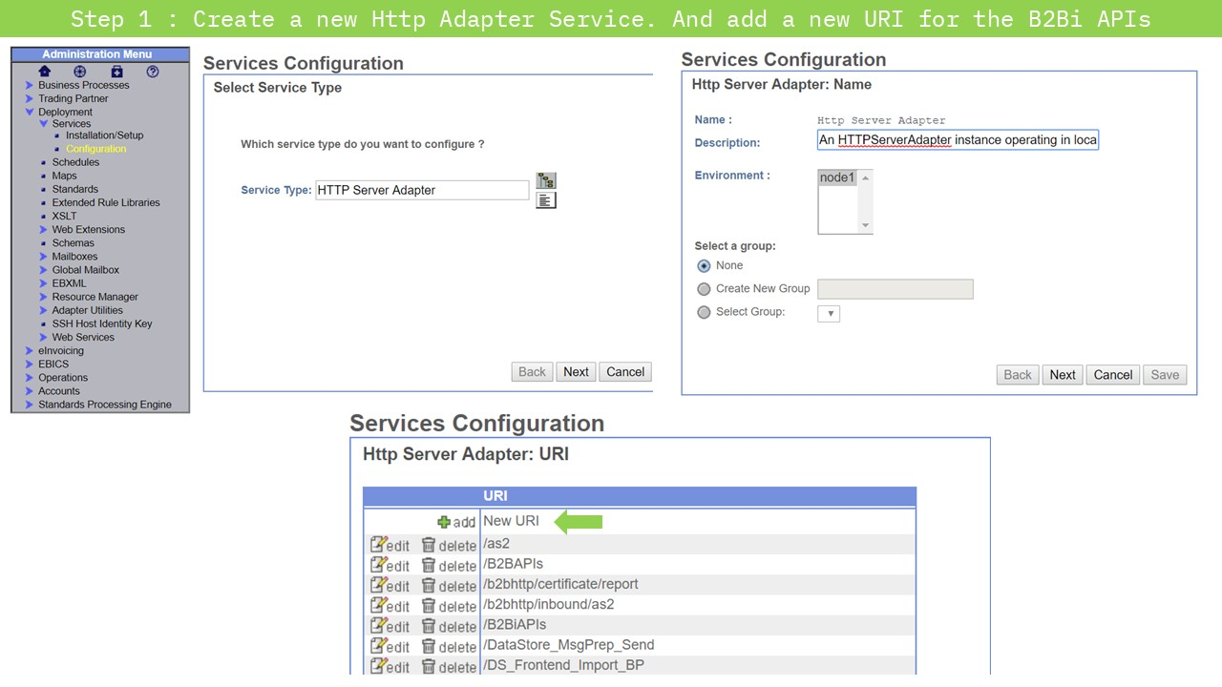

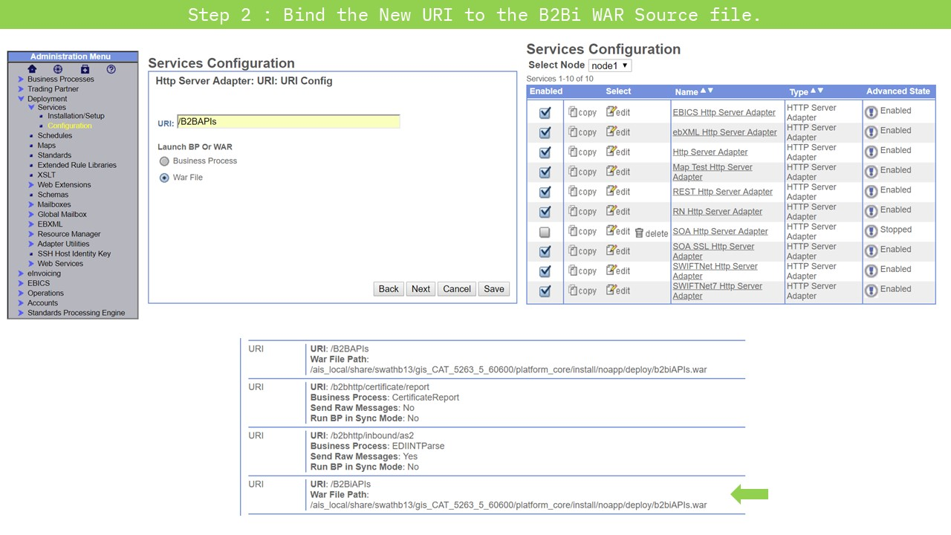

Now, after the successful creation of the HTTP Adapter service, Web.xml file is to be edited to set the default page to open. In the case of B2Bi APIs, is called **/svc/*.** After making this change, the WAR package is transferred to the **install/noapp/deploy** directory on the SI server. Also, the WAR package is unpacked for the SI to recognize the link of the new URI (created in the previous step) to this unpacked directory.

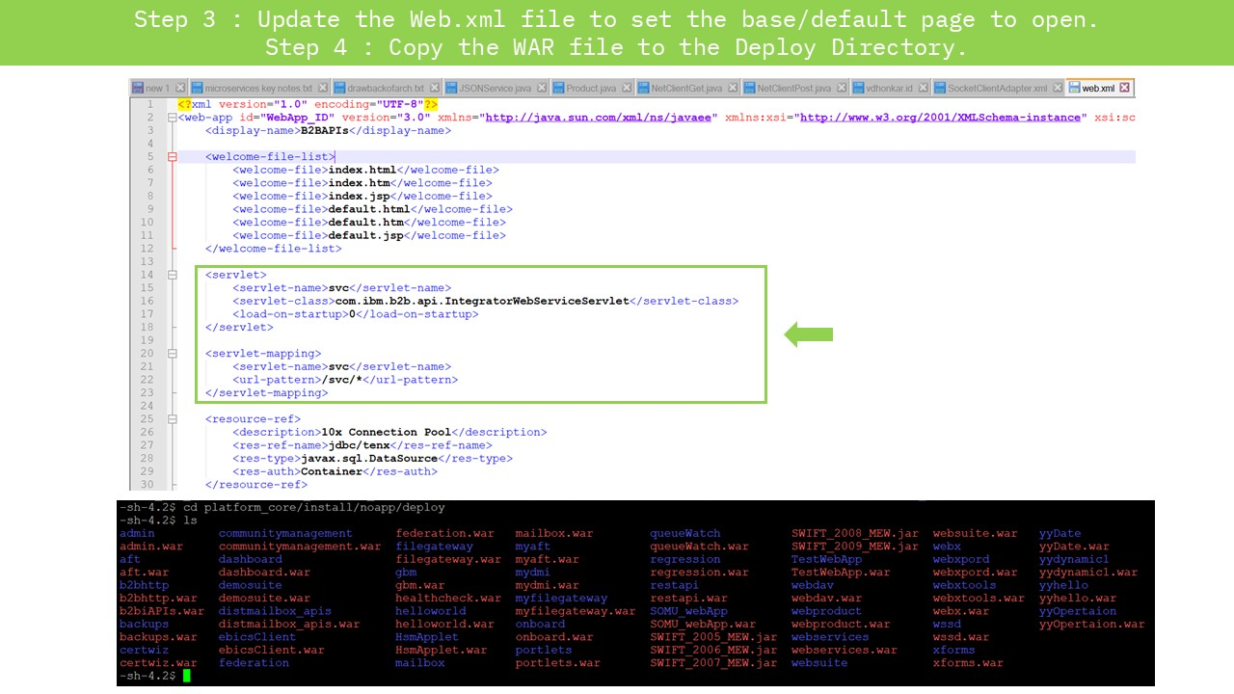

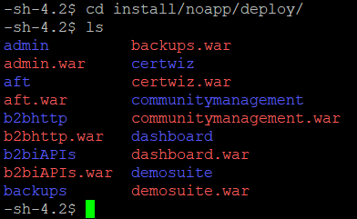

# C:\Users\ArpitJainMr\AppData\Local\Microsoft\Windows\INetCache\Content.Word\Slide5.jpg

Finally, after the deployment of the B2Bi WAR file (nearly takes 2-3 Hours), the APIs can be accessed at the previously specified URI. The web interface thus opened, shows the list of all the APIs along with their Call methods.

# Results and Discussions

The core of B2Bi is composed of multiple business processes which are used to automate the operation of B2B services (Mailbox, Invoice, Order; etc). Separate microservices can be deployed on the B2B SI platform server to enhance its functionality. By the deployment of B2Bi APIs on the sterling integrator platform, REST API calls can be placed to interact with the product.

B2Bi APIs are composed of a set of multiple APIs like mailbox, certificates, codelists, useraccounts; etc. Services in the sterling Integrator are utilised using these APIs only. My next aim is to automate this invocation of REST services using a REST API Client business process which will place calls to the B2Bi APIs.

# Conclusions

During past few weeks, I got acquainted to the Deployment models on the B2B Sterling Integrator. I also researched about the B2B processes and learned to code them using XML semantics. Using the knowledge of Sample WAR deployment during the previous report session, I deployed B2B standard services to the server of Sterling Integrator.

**Next Target**

My target for the next 15 days is to create a REST API Client service and Business process for the Sterling Integrator B2Bi Services. This will help in the automation of **CRUD (Create/ Read/ Update/ Delete)** operations on the B2B APIs (which I deployed in this report).